Computer Language Coding Concepts

Target Command Object in a Diagram
The principle of target command objects is explained in the article Target Command Object. This article demonstrates its expression in a diagram.

The target command object is the last point in a string of object redirections of command symbols.

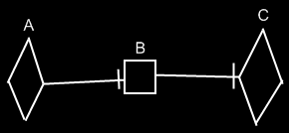

Symbol A is an active command reference to symbol B. Symbol B is an inactive command reference to symbol C. Symbol C is the target command object of both symbols A and B. Symbol C represents the command object itself.

See also: Target Command Object

Author & Copyright: Jan-Joost van Zon Date: August 17, 2008 – August 23, 2008 Location: Oosterhout, The Netherlands Status: Finished

